1. If a collection contains blank row the corresponding loop will?
2. throw an internal error
3. loop will be executed once
4. loop will be executed till number of item available in collection
5. loop will stop at blank row
6. None

Answer- C

1. In browser base application what are the different spying mode
2. Html,Win32,Accessibility
3. Html,Win32,Accessibility and Region
4. Html, Accessibility and Region
5. Html,Win32 and Region

Answer- b

1. Correct sequence of Delivery Road map
2. Define>Process Management>Develop>Design>Test
3. Process Management >Define>Design>Develop>Test
4. Design>Process Management > Define>Develop>Test
5. Process Management >Design>Develop>Test>Define

Answer- b

1. Which is the correct flow diagram?
2. Case A
3. Case B
4. Case C
5. None

Answer – C

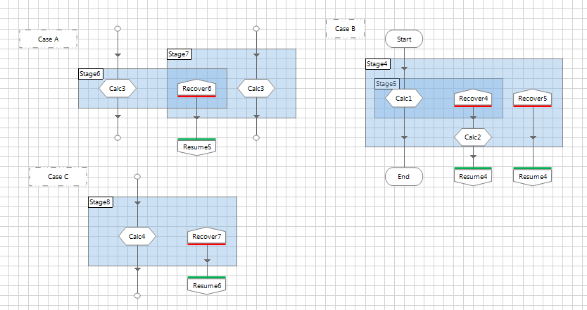

1. Data is transferred between a Process and a Business Object via
2. only input parameter
3. input and output parameters
4. by calling different action
5. none of these

Answer B